Got an Ipad or Smartphone?
Download a free QR reader app like neoreader or i-nigma to check out these booktrailers. If you like what you see, email us and we’ll reserve a copy for you. These are all in the library.
Mrs. Archambault & Mrs. Vaughn

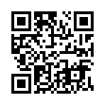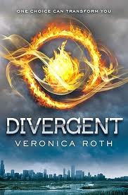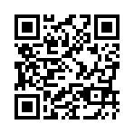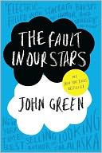

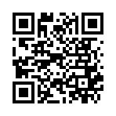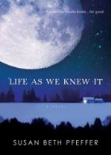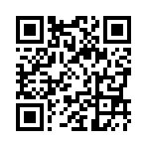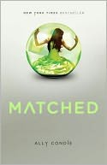

Be on the lookout for more QR codes around campus. You never know where you’ll find your next favorite book!

